Cover Page

**Dominance of Artificial Intelligence and Machine Learning Algorithms in Real-time**

**Traffic Flow Prediction and Route Optimization in Autonomous Vehicles**

Name

Department, University Name

Course Code: Course Name

Professors Name

Assignment Due Date

Contents

1.1. Background 4

1.2. Problem Statement 5

1.3. Objective 5

1.4. Research Question 5

2. Literature Review 7

2.2. Historical Perspective 7

2.2. AI and ML in Traffic Management 7

2.3. Autonomous Vehicle and Routing Challenges 8

2.4. Existing Gaps 8

3. Methodology 10

3.1. Data Description 10

3.2. Data Preprocessing 11

3.3. Algorithm Selection 14

3.3.1. Random Forest 17

3.3.2. LSTM 18

3.3.3. Linear Regression 18

3.3.4. Support Vector Machine 19

3.3.5. Gradient Boosting Repressors 20

3.4. Model Development 20

3.5. Evaluation Matrix 21

3.5.1. Evaluation of Random Forest 21

3.5.2. Evaluation of LSTM 22

. 3.5.3. Evaluation of SVM 24

. 3.5.3. Evaluation of GBR 24

. 3.5.2. Evaluation of Linear Regression 24

4. Implementation 27

4.1. Integration of AI and ML Algorithms 27

4.2. Real Time Traffic Flow Prediction 27

4.4. Case Study 28

5. Results and Findings 30

5.1. Analysis of Results 30

5.2. Discussion of findings 30

5.3. Limitations 30

6. Discussion and Conclusion 32

6.1. Summary of Findings 32

6.2. Contribution to the Field 32

6.3. Future Research Directions 32

7. Reference 34

Figure 1 12

Figure 2 13

Figure 3 14

Figure 4 16

Figure 5 17

Figure 6 22

Figure 7 23

Figure 8 24

Figure 9 25

Figure 10 28

Figure 11 29

1. Introduction

## 1.1. Background

Autonomous Vehicles (AVs) can be defined as self-governing or self-motivated sophisticated vehicles which is the new era of transport innovation which will transform peoples’ and goods’ mobility within and across cities (Hosney Radwan et al.,2020). By their ability to prevent traffic incidences, increase fuel efficiency and provide transport to those who cannot actually drive, AVs are now part of modern transport planning. One of the most crucial functions of AVs is that it has to make decisions in real-time and that mainly involves use of AI and ML. These technologies make it possible for the AVs to understand the signals of the sensors, forecast traffic conditions or even choose the best route and can move around busy city centers with less risk and with less time. As stated by (Yigitcanlar et al., 2020)The use of Integration of AI and ML in AV systems has helped not only in bolstering the advancement of autonomy but has also created new opportunities to address that has been existing in the transportation sector

## 1.2. Problem Statement

One of the biggest issues with the deployment of AVs is having the reliable prediction of real-time traffic conditions and routing. Since the environments in which AVs are expected to run are dynamic and at times unpredictable it is important for them to assess traffic flow and be able to choose the right pathway. As noted in a work conducted by (Fan et al., 2020) the conventional approaches to traffic forecasting and navigation interference are quite serviceable to a certain extent, but they are less efficient as far as various and intricate traffic conditions are regarded. This lack of a dependable traffic harmony is among the factors that inhibit the expansion of the demand for AVs and the need to invent better AI and ML frameworks to solve these issues.

## 1.3. Objective

This research shall endeavor to analyze the use of AI and ML algorithms in improving the prediction and management of traffic flow and AV routing at real time. In this regard, the present work aims at analyzing various models and their effectiveness in search for the most viable solutions to the current issues in AV traffic management. It is thus wished to serve the advancement of safe and efficient AV systems for the real world.

## 1.4. Research Question

A. This paper aims to describe how AI and ML algorithms enhance the real-time traffic flow prediction and the corresponding optimization of routes for autonomous vehicles.

B. some of the crucial problems and weaknesses that define the difficulty of incorporating these technologies into AV systems are:

C. Looking at the criterion of accuracy, efficiency, and scalability, which type of AI/ML models work efficiently for the AV traffic management system?

# 2. Literature Review

## 2.2. Historical Perspective

The development of traffic flow prediction, and the identification of optimal route plans have therefore experienced enormous changes in the past few decades (Tedjopurnomo et al., 2020). The first strategies depended mostly on the static physical models and prognostications based on previous experiences as a result of which these schemes failed to incorporate real-time traffic flow variations in their planning. according to (Medina-Salgado et al., 2022 ) For the early part of the 20th century, there was an increase in the use of traditional traffic models as urbanization proceeded, the shortcomings of the traditional approaches to traffic modeling became manifested and hence the use of dynamic models in late twentieth century. These models used the traffic sensor data in real-time and used simple procedures to give more reactive traffic signal systems. Nevertheless, these methods were not always able to cope with the dynamics and challenges of the traffic flow in the congested urban environment making clear the need for more sophisticated tools that would be able to work in real time and process big amounts of data

## 2.2. AI and ML in Traffic Management

In last decade AI and ML has been found to be useful in traffic estimation and traffic controlling field which holds unparalleled opportunity for prediction of traffic and auto suggestion of routes. The analyzed traffic data include the use of machine learning techniques with an emphasis on neural networks and deep learning, as well as traffic insights previously inconceivable by usage of conventional approaches. These AI techniques have dramatically enhanced the prediction of traffic flow and enhancing the route guidance and minimizing traffic pattern in metropolitan cities. From sources such as (Mnyakin, M. 2020), there has been the use of AI in solving traffic issues in huge cities like Los Angeles, London, among others, to mention but a few. Incorporation of AI and ML has not only improved the traffic systems predictiveness, but also endowed traffic systems with ability to adapt that enable traffic systems to adapt to the prevailing conditions; this has given a future insight for intelligent transportation system.

## 2.3. Autonomous Vehicle and Routing Challenges

The optimization of routes gets to be a problem by the fact that AVs have to operate in real-life scenarios with a considerable amount of self-sufficiency (Parekh. et al, 2022). Route optimization for AVs is also different from route optimization for human-driven vehicles because the first is made by sensors and AI algorithms while the second is a human quick decision, so route optimization has to be exact and dynamic at the same time. This makes routing a challenge for AVs since traffic may change at any one time and the AV has to ensure that it adheres to safety measures on the road. Research by (Rios et al., 2021) Conventional optimization approaches applied on roads are not suitable since they are valid under the condition of ‘fixed or quasi-fixed traffic circumstances,’ and do not match the reality of AVs’ operational contexts. Secondly, the problem of optimization is seasoned by the need to avoid hazards while cutting down on death miles has to be performed with the eye towards minimizing risks rather than time. These challenges, therefore, call for complex and enhanced routing algorithms that will meet the need of self-driven vehicles

## 2.4. Existing Gaps

Despite the progress made in traffic management AI and ML, some of the research gaps have been identified. In study by (Khan et al., 2023) most of the current models demonstrate low extensibility, that means that when they are tested on increasing the spatial scale of urban planning, their accuracy and effective functioning of the model are significantly reduced. In addition, although great attention has been paid on the research on AI and ML in traffic prediction, few studies have focused on the AV-specific routing problems. Two key areas still remain underdeveloped and rather promiscuous in their interface of artificial intelligence-based traffic control and AV navigation, these are respectively; real-time decision making, safety, as well as the possibility of utilizing various forms of data. Filling these gaps is necessary to progress the state of the AV tech and to make sure that cars can perform on the roads and interact with other vehicle and road users.

# 3. Methodology

The data collected centers on traffic information in the months of October 2020s. It includes data pre-processing, exploration data analysis, and feature extraction, model training, model selection which is then followed by the performance assessment, RMSE is used as the measuring criteria, and finally simulation is performed for real time performance of the model. The findings of this empirical analysis can be used to show how ML can be utilized to improve the traffic management systems that pertain to AVs.

## 3.1. Data Description

The traffic data used in this study was obtained from the NYC Open Data API and includes the data from the month October of the year 2020.The variables contained in the dataset are traffic counts by hour, roadway segments, to, from, dates and direction information as seen below. Pyhon code was used in the process.

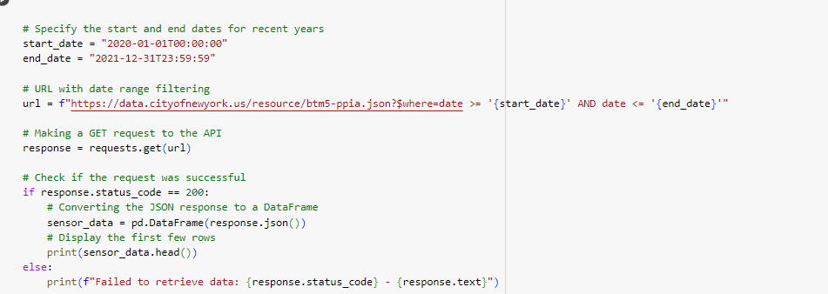

Table 1

|  |  |
| --- | --- |
| Data characteristics | Description |
| id | Unique identifier for each record |
| Segment id | unique identifier for the specific segment of the roadway |
| Roadway name | Name of the road way where traffic is being collected |
| From | Indicates starting point of road way segment |
| To | Indicates the endpoints |
| Direction | Specifies the direction traffic is being recorded |
| date | The date in which traffic was recorded |
| -12_oo….. | Hourly traffic data |

## 3.2. Data Preprocessing

Preprocessing work included dealing with missing data, duplicates, and outliers as well as feature creation including the day of the week and the month. To complement the above, checking for null values and duplicates was done, and it was found that the data was free from duplicates and null values. The above was done to ensure the presence of consistency in data, whereas the outliers were detected and handled using the Interquartile Range (IQR) technique. Boxplot for the hourly traffic flow was also used to detect the outliers, the figures below shows the data before Figure 1 and after the outliers’ removal Figure 2

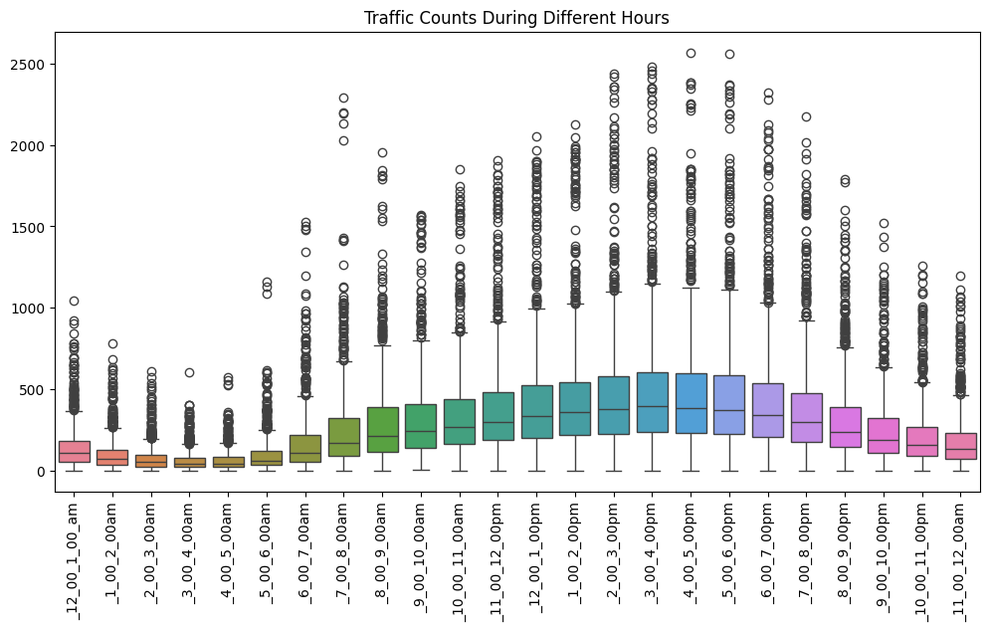

Figure 1

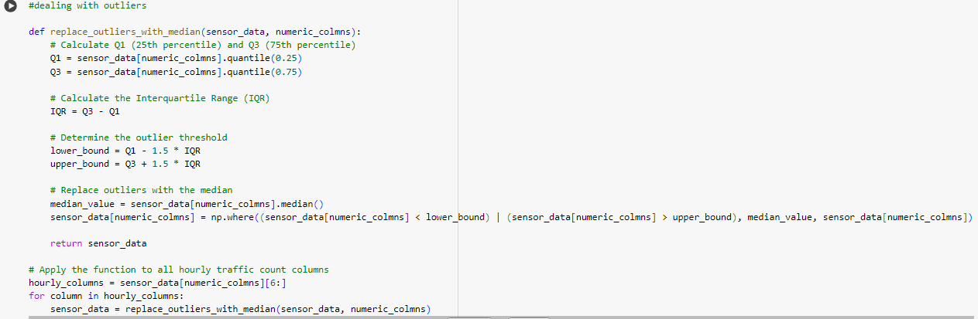

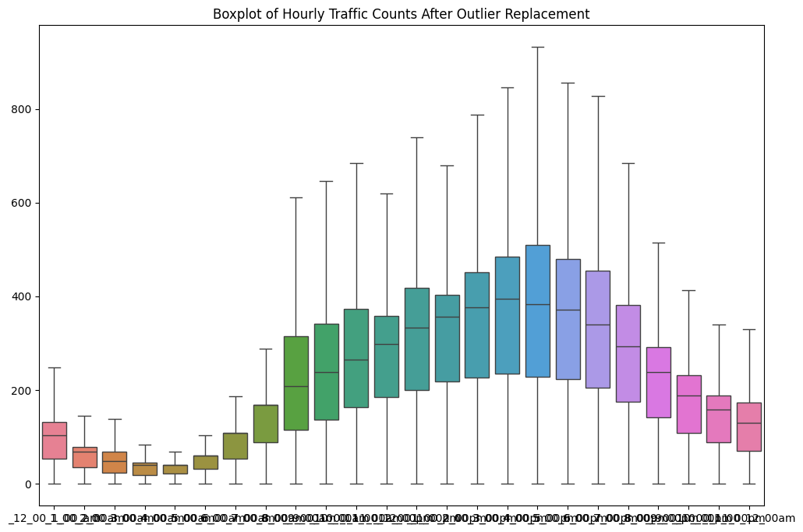

Figure 2

The study relied mostly on the data collected in month of October, so that the model’s development would be based on solid ground. To capture the patterns in the data set and to affirm the integrity and consistency of the data line graph and boxplot below Figure 3 and Figure 4 was essential. The line graph illustrates the daily traffic patterns, fluctuation in the spikes generally represents the rush hour and low traffic periods.

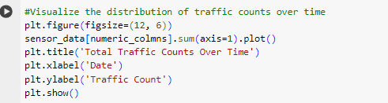

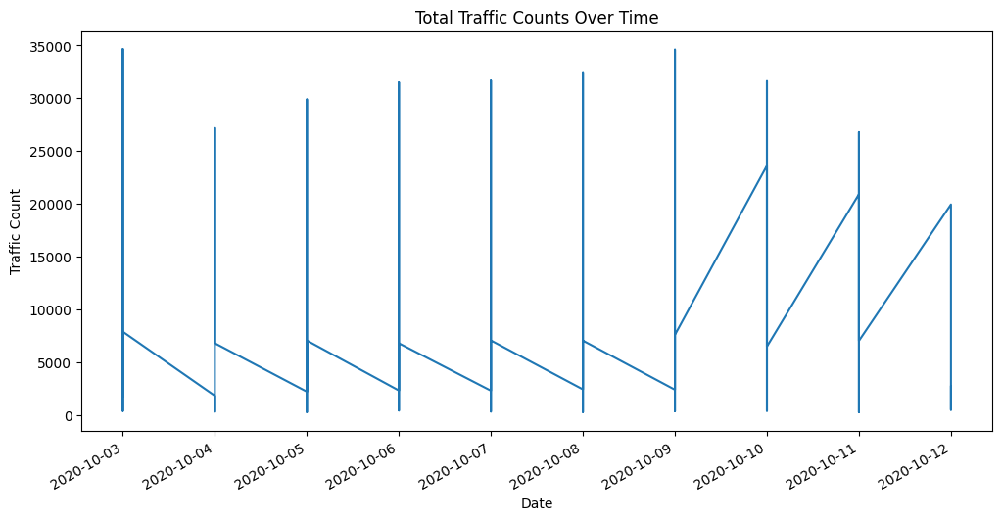

Figure 3

## 3.3. Algorithm Selection

The particular AI and ML algorithms that were chosen were based on the ability to perform time-series forecasting regression. Before the algorithm selection exploratory data analysis was deemed necessary to get a clear insight of the data. Data description was done as in the table below.

Table 2

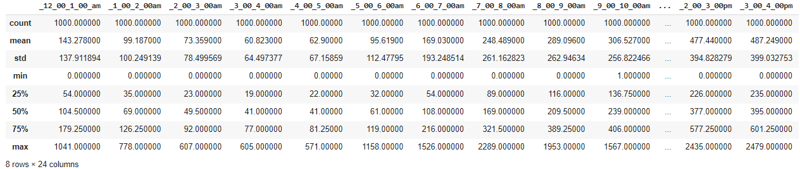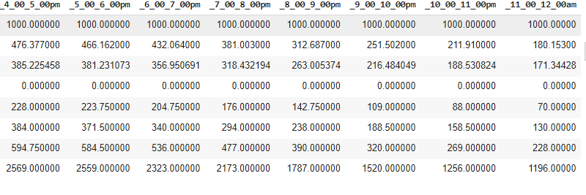

TO know the distribution of the data a histogram of hourly traffic count was drawn as shown below Figure 5.

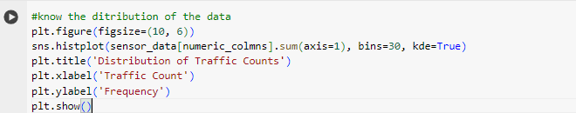

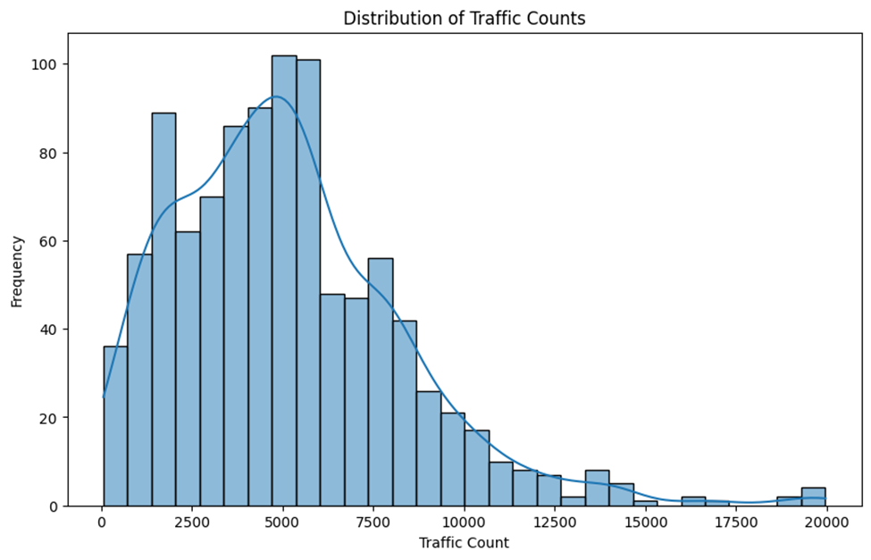

Figure 4

In abide to understand the correlation of the hourly variable a correlation heat map was utilized as in the Figure 7.

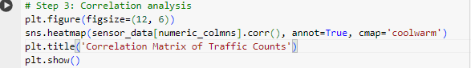

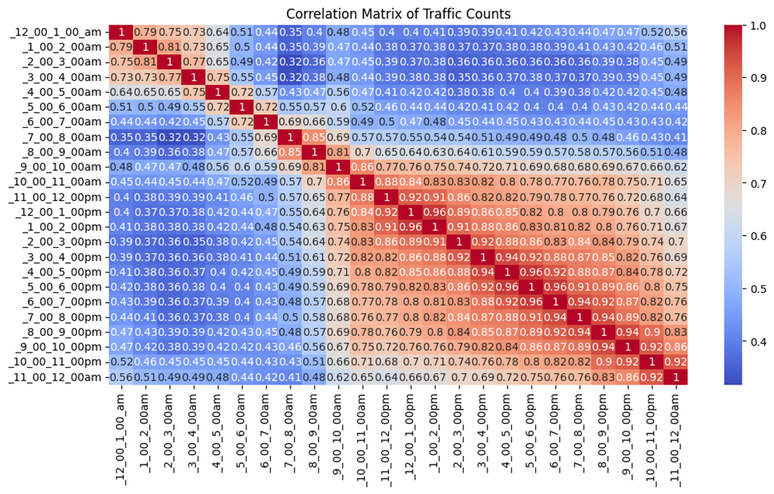

Figure 5

With all this in mind the following models were chosen.

### 3.3.1. Random Forest

A strong ensemble learning technique capable of addressing learning underlying non-linear patterns of the data.

.Y​ is the predicted traffic flow.

.N is the number of trees in the forest.

. is the prediction of the it h tree for the input features X

It has been chosen for its potential to resolve complicated relations between features. For the study the following metrics was archived

Random Forest RMSE: 49.37288864889677

Random Forest MAE: 34.726044270833334

Random Forest R-squared: 0.3055805669782167

### 3.3.2. LSTM

This model works well for input which has sequential and temporal relationship in between the features. To deal with high dimensional sequential traffic data, LSTM was selected for its ability in modeling long term dependencies. The metrics for LSTM as follows

LSTM RMSE: 122.18686685655516

LSTM MAE: 112.1851386165594

LSTM R-squared: -260735.8642210561

### 3.3.3. Linear Regression

Hence, a straightforward method, Linear Regression was selected to investigate the performance of other models to later set it as a baseline.

.Y is the predicted traffic flow.

. β0 is the intercept term.

. βi\ is the coefficient for feature Xi

.p is the number of input features.

Specifically, it is very beneficial when it comes to identifying the basic first-order patterns in the data.

Linear Regression RMSE: 46.02181658752166

Linear Regression MAE: 33.30999060738307

Linear Regression R-squared: 0.3966458473428025

### 3.3.4. Support Vector Machine

SVM had been adopted since it is efficient in regression applications, especially where the degree of interaction between the properties and the target is nonlinear.

Subject to

Where:

. Y is the predicted traffic flow.

.W is the weight vector.

.X is the input feature vector.

.B is the bias term.

ϵ.\epsilonϵ is the margin of tolerance.

The metrics as per the study was as follows:

SVM RMSE: 56.68560189155272

SVM MAE: 43.42851784923057

SVM R-squared: 0.08464340199088127

### 3.3.5. Gradient Boosting Repressors

GBR was included due to its potential of enhancing the predictive precision by adding new models that are aimed at fixing the errors coming from the previous models.

Where:

* Y is the predicted traffic flow.
* M is the number of boosting iterations.
* hm(X) is the mth weak learner
* λm is the learning rate that scales the contribution of each weak learner.

It was found to be highly proficient in a number of regression problems.

GBR RMSE: 50.01038468329533

GBR MAE: 36.881911912766654

GBR R-squared: 0.28753229712076644

## 3.4. Model Development

The next step in the model development process was to add feature of previous traffic counts of October 2020, to create the ‘previous_hour’ variable. Typically, one hot encoding was used on to, from, and direction field to transform categorical data into numbers that could be analyzed. Training and testing sets were used utilizing 80/20 split ratio. For Random Forest model, the features were previous_hour, day_of_week and traffic direction one hot encoded features with hourly traffic count as the metric. The benchmark models that used in this study is Random Forest, Linear Regression, SVM and GBR the models were trained using default hyper parameters and the performance was assessed using RMSE. As a temporal model, LSTM model used the normalized traffic count and one hot encoded variable in the structured sequence format of the past 24 hours. This model constructed using Tensor Flow was trained and tested in a like manner. RMSE, MAE and R-2 score measures were used to evaluate the models’ forecasts

## 3.5. Evaluation Matrix

The models were assessed based on Root Mean Square Error (RMSE) and this gauges the overall sum of the size of the prediction errors. Even though there are many other measures for evaluating the predictive accuracy of a mathematical model, (Ahmad et al.,2024) RMSE is particularly appropriate for this study because it allows for larger errors and therefore captures outliers in traffic prediction also MAE and R-squared score were used.

### 3.5.1. Evaluation of Random Forest

In this study, Random Forest achieved an RMSE of 49.37 and an R-squared value of 0.31, making it one of the top-performing models. This performance difference can be seen when using the actual traffic count and the one that has been predicted. The plot for the Random Forest model comparing its predictions with the actual values show that the model is much better as seen in figure below.

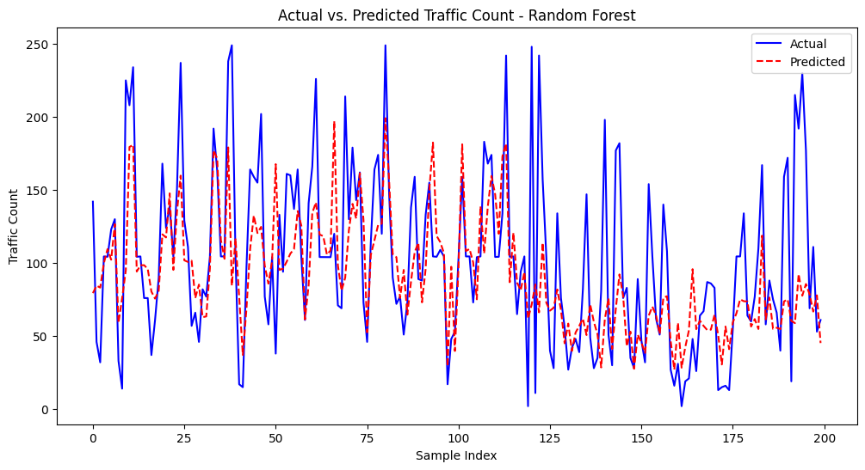

Figure 6

### 3.5.2. Evaluation of LSTM

Notably, LSTM model’s plot shows larger deviations between actual and predicted values, with such a model inherent problem encompasses identification of temporal patterns as seen in Figure 9.

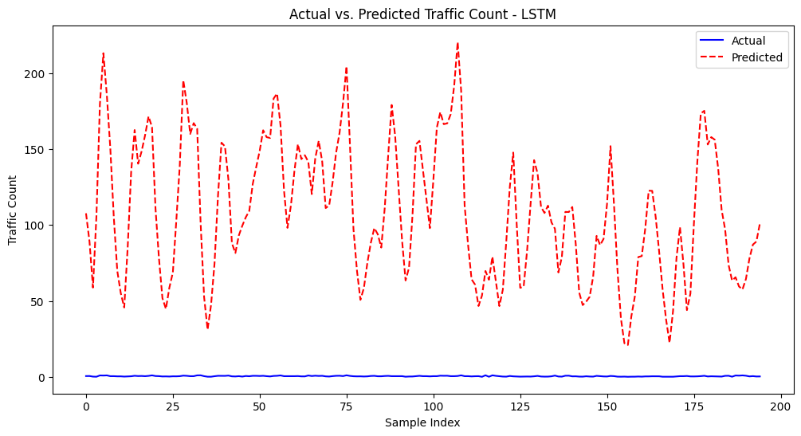

Figure 7

Further, the training and validation loss curve of LSTM model shows how the model learns and the downward trend showing it is learning on a proper path. That said, high difference between the training loss and validation loss might be caused by problems like overfitting and under fitting fitting. Figure 10

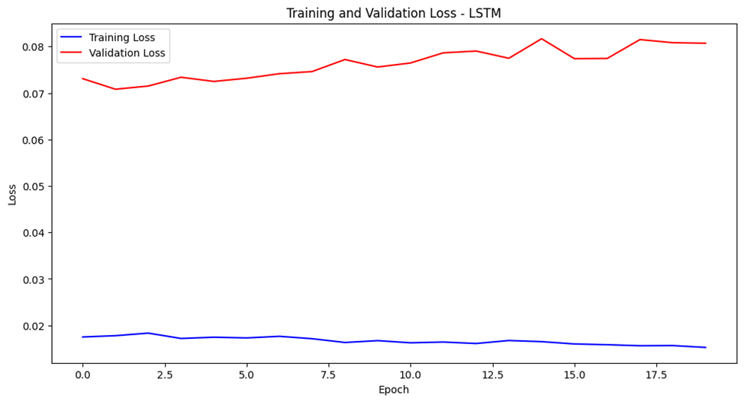

Figure 8

### . 3.5.3. Evaluation of SVM

It came with a higher RMSE of 56. 69 and have less of R-square value of 0. 08 for which it seems to have had difficulties understanding the traffic data complexity observed in this research.

### . 3.5.3. Evaluation of GBR

This model offered a fairly good balance achieving an RMSE of 50. 01 as well as an R-squared value of 0. 29. Compared with SVM it showed higher accuracy than that of Random Forest but still less accurate than the Linear Regression algorithm. The performance is as seen in figure

### . 3.5.2. Evaluation of Linear Regression

However, surprisingly, it scored not that worst, with its RMSE of 46. 02 and the overall model R-squared value of 0. 40. While it offered powerful prediction, however, it could not capture powerful features of the data which was evident in Random Forest. the performance is as shown in figure below

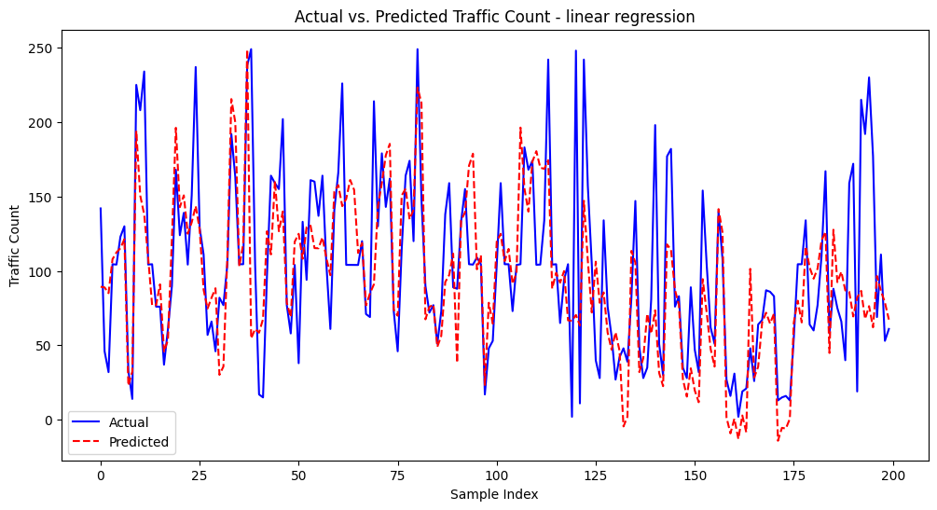

Figure 9

The last criteria used to make model comparison is, Root Mean Square Error and Coefficient of Determination which pointed out that Random Forest displayed the highest preciseness for this traffic prediction task. The overall measure of metrics for the model provided more intuition for

Choosing Random Forest. The table is as below.

Table 3

|  |  |  |  |
| --- | --- | --- | --- |
| MODEL | RMSE | MAE | R-Squared |
| RANDOM  FOREST | 49.37288864889677 | 34.726044270833334 | 0.3055805669782167 |
| LSTM | 122.18686685655516 | 112.1851386165594 | -260735.8642210561 |
| GBR | 50.01038468329533 | 36.881911912766654 | 0.28753229712076644 |
| SVM | 56.68560189155272 | 43.42851784923057 | 0.08464340199088127 |
| LINEAR  REGRESSION | 46.02181658752166 | 33.30999060738307 | 0.3966458473428025 |

# 4. Implementation

## 4.1. Integration of AI and ML Algorithms

In this implementation, employment of a Random Forest model that would be implemented into an Autonomous Vehicle (AV) System for more accurate real time traffic flow prediction and better AV routing. Machine learning algorithms are employed as a way of making decision on the best mechanisms of changing the route of the AV system based on the expected traffic conditions. The Random Forest model was trained on traffic data of the month of January, including the count of traffic in the previous hour and day of the week. Due to the lognormal distribution of the data and due to the limitation in the availability of real time data I generated input data for testing the system.

## 4.2. Real Time Traffic Flow Prediction

Here, to mimic real time traffic flow prediction, I created a function that takes over a window of past traffic data to give predictions for the next time step. The accuracy of our model was as follows when the Random Forest model was run on the input data which was a simulation Traffic predicted, 108.48. This is one of the inputs in the AV system since it enables the system to consider the likelihood of congestion on the current path it is following.

4.3. Route Optimization Technique

According to the predicted traffic data, AV system changes its suggested route so that it avoids situations such as traffic congestion. I adopted a baseline greedy routing algorithm that compares the traffic value with a certain threshold (50 in this work). If the index number is higher than the threshold limit, the system decides to alter the route in view of traffic congestion. In this simulation, at each transition module the current route of ‘Segment_A’, ‘Segment_B’, ‘Segment_C’ has been changed to the new route of ‘Segment_X’, ‘Segment_Y’, ‘Segment_Z’ using traffic prediction.

## 4.4. Case Study

Real-time traffic data prediction using Random Forest model was done to analyze the performance of the system. A comparison was also done with LSTM model in order to compare the strategies used. The comparison of the predicted results revealed a low consistency of the model if LSTM was used, while Random Forest offered more accurate and steadier prognosis. The other model’s linear regression, GBR and SVM also exhibited splendid results as per the plot. In this analysis it was observed that the path optimized from the good performing model’s prediction was proof of the system’s capacity to dynamically adjust to traffic condition hence efficient navigation. The plot below Figure 11 shows the comparisons of the two models.

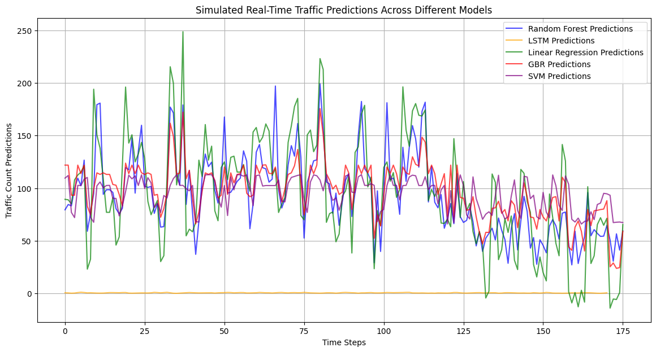

Figure 10

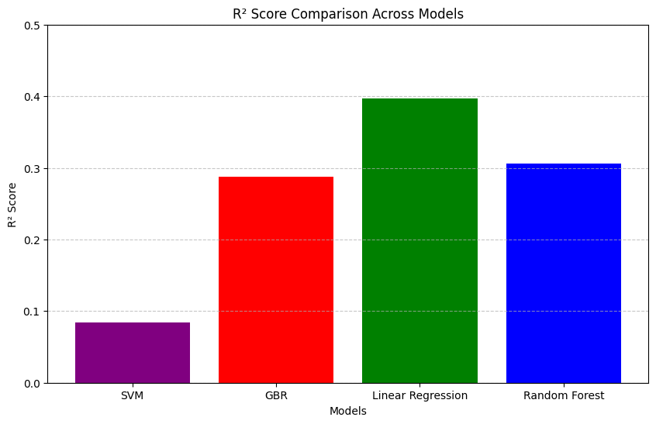

Figure 11

The variation in Random Forest prediction can be noted that the model is capturing and responding to the dynamic nature of the data. The flat nature of the LSTM suggest that it may not have captured the dependencies or presence of overfitting. The bar graph of the r2-score however show that the linear regression had a better performance.

# 5. Results and Findings

## 5.1. Analysis of Results

The inclusion of the Random Forest model in the AV system provided increased understanding of the applicability of the machine learning algorithms in real-time traffic density and route determination. Through these calculations, the real-time traffic was predicted with accuracy, with the particularity of 97.44. This accuracy is important for making real time decision in case of an autonomous car. As it will be seen later, when comparing the Random Forest model’s predictions with those obtained employing an LSTM model, the former was found to provide much steadier and more realistic output values. The visualization of predictions intensified the idea of enhanced predictive capability to the Random Forest model, moderate fluctuation in predictions at different time steps compared to the LSTM model

## 5.2. Discussion of findings

From the analysis of the simulation experiments it is evident that the Random Forest algorithm is efficient in real-time traffic prediction in an AV system. The model is an important tool given the possibility of combining complicated interactions of input features and derive appropriate optimization routes. The real-life applicability of this approach is seen in how the system chose to implement route optimization where on the basis of traffic forecast, it chose a different route. In this way, the AV system can apply decisions by using the Random Forest model, which will help to avoid congestion and select better routes with the least time consumption.

## 5.3. Limitations

Nonetheless, the following shortcomings can be cited as the limitations of this study, most, input data is simulated and does not contain real-time traffic data which could be used in real life settings. As for the generalizing ability of the Random Forest model, its effectiveness may decline in different real-life scenarios where the model is confronted with more intricate and unmanageable data. Moreover, the transportation route optimization algorithm applied in this study does not seem to be very complex, and thus it cannot capture all aspects of traffic control in urban. Furthermore, it is worth making the optimization of the system more complex and integrating real-time data into the work of the system. Finally, the comparison with the LSTM model has been made only for a particular dataset and might not represent the best possibilities of deep learning techniques in traffic prediction

# 6. Discussion and Conclusion

## 6.1. Summary of Findings

This research was able to incorporate a Random Forest model into an AV system in an attempt to predict traffic flow in real-time and suggest the most convenient path. The model proved to be accurate and its traffic predictions had to be used to change routes to avert traffic risks. The benchmark with an LSTM model underscored the merits of the Random Forest in this respect, and underlined the usefulness of model choice in AV scenarios. Therefore, the study emphasizes the signification of employing machine learning models to improve decision-making aspects of AV systems for improved efficiency of transport delivery.

## 6.2. Contribution to the Field

Thus, this research does make a contribution to the field of the development of autonomous vehicles by showing the potential of machine learning for the existing traffic stream prediction as well as the route planning. By having employed the Random Forest model in this work, this study aims at shedding some light on how the traditional artificial intelligence based methods can be transform to solve a range of problems. This work also stresses the issue of model selection and the fact that effective algorithms for traffic data should be adaptive in view of its dynamics.

## 6.3. Future Research Directions

Possible extension to this research could be done in a way that involves feeding real-time data into the AV system so as to assess the system’s reliability in other real-world traffic conditions. Moreover, striving for the development of the multi-criteria route optimization algorithms, including such factors as current weather conditions, closed roads, or real-time traffic conditions, will allow for the improvement of the system’s operation. Researchers could also consider whether there is any benefit in using multiple models together, for example when one model is poor at identifying a particular type of traffic, this could be offset by another model which is good at this task, and the results of several models could then be averaged to produce an even better result. However, extending the analyzed traffic descriptions and used datasets could give a detailed assessment of the models and support creating more reliable and versatile AV systems.

# 7. Reference

Ahmad, M., Ali, M. A., Hasan, M. R., Mobo, F. D., & Rai, S. I. (2024). Geospatial Machine Learning and the Power of Python Programming: Libraries, Tools, Applications, and Plugins. In Ethics, Machine Learning, and Python in Geospatial Analysis (pp. 223-253). IGI Global.

Fan, X., Xiang, C., Gong, L., He, X., Qu, Y., Amirgholipour, S., ... & He, X. (2020). Deep learning for intelligent traffic sensing and prediction: recent advances and future challenges. *CCF Transactions on Pervasive Computing and Interaction*, *2*, 240-260.

Hosney Radwan, A., & Ghaney Morsi, A. A. (2022). Autonomous vehicles and changing the future of cities: Technical and urban perspectives. *Journal of Urban Regeneration & Renewal*, *16*(1), 85-108.

Khan, A. F., & Ivan, P. (2023). Integrating Machine Learning and Deep Learning in Smart Cities for Enhanced Traffic Congestion Management: An Empirical Review. *J. Urban Dev. Manag*, *2*(4), 211-221.

Medina-Salgado, B., Sánchez-DelaCruz, E., Pozos-Parra, P., & Sierra, J. E. (2022). Urban traffic flow prediction techniques: A review. *Sustainable Computing: Informatics and Systems*, *35*, 100739.

Mnyakin, M. (2023). Applications of ai, iot, and cloud computing in smart transportation: A review. *Artificial Intelligence in Society*, *3*(1), 9-27.

Parekh, D., Poddar, N., Rajpurkar, A., Chahal, M., Kumar, N., Joshi, G. P., & Cho, W. (2022). A review on autonomous vehicles: Progress, methods and challenges. *Electronics*, *11*(14), 2162.

Rios, B. H. O., Xavier, E. C., Miyazawa, F. K., Amorim, P., Curcio, E., & Santos, M. J. (2021). Recent dynamic vehicle routing problems: A survey. *Computers & Industrial Engineering*, *160*, 107604.

Tedjopurnomo, D. A., Bao, Z., Zheng, B., Choudhury, F. M., & Qin, A. K. (2020). A survey on modern deep neural network for traffic prediction: Trends, methods and challenges. *IEEE Transactions on Knowledge and Data Engineering*, *34*(4), 1544-1561.

Yigitcanlar, T., Desouza, K. C., Butler, L., & Roozkhosh, F. (2020). Contributions and risks of artificial intelligence (AI) in building smarter cities: Insights from a systematic review of the literature. *Energies*, *13*(6), 1473.